## System Design Diagram

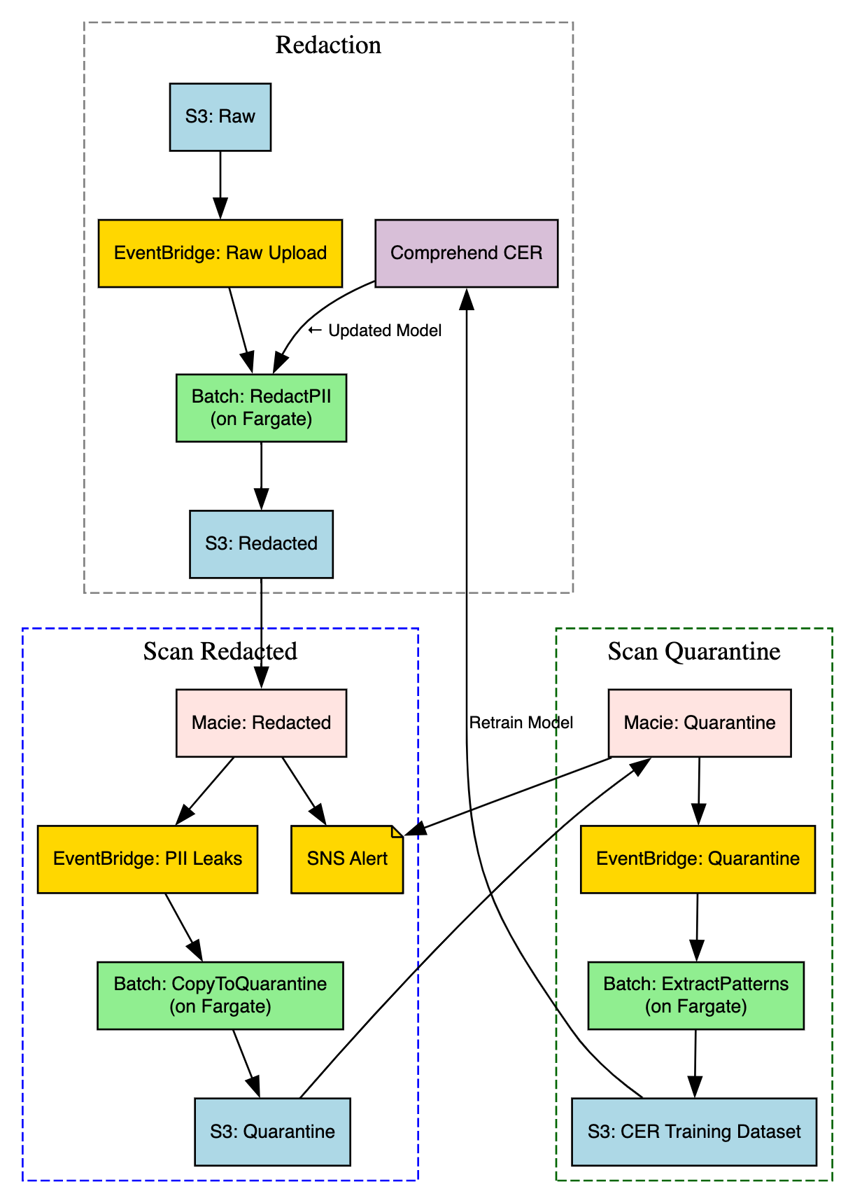

The architecture is designed to process high-volume voice metadata files, redact sensitive content using Amazon Comprehend, validate using Macie, and continuously improve through feedback and retraining.

## 🔄 Data Flow Description

### 1. 📨 Raw File Ingestion

Raw files are uploaded daily to a structured S3 bucket. This triggers an EventBridge Raw Upload rule, with the Batch job RedactPII for redaction as a target. This separation of concerns ensures that trigger logic remains minimal and scalable, while the heavy lifting is offloaded to the compute-efficient Batch job system

### 2. 🧼 Redaction via Batch Job using Comprehend

The redaction is performed using a Batch job RedactPII on AWS Fargate. It leverages a Comprehend Custom Entity Recognizer (CER) model to detect and redact PII from the sentence fields in each payload. The output is stored in a separate S3: Redacted bucket. Using a Batch Job allows for longer execution windows, and better performance when dealing with large files.

### 3. 🕵️ Validation with Macie

To verify redaction quality, files in S3: Redacted are asynchronously scanned by **Amazon Macie**, which uses ML to flag any residual PII. This creates a safety net over Comprehend and acts as an external layer of validation. Findings are routed to EventBridge PII Leaks, enabling downstream automation without tight coupling.

### 4. 🚨 Quarantine on Redaction Failures

When PII leaks are detected, EventBridge PII Leaks triggers the CopyToQuarantine Batch job. This job copies the original raw files (those linked to Macie-detected leaks) to a separate quarantine bucket. Using Batch here ensures the system can handle copying large numbers of files at once without running into Lambda limitations.

### 5. 🧪 Scan Quarantined Files with Macie

To extract patterns of missed PII, **Macie** scans the raw files in S3: Quarantine. These results — published to EventBridge Quarantine — provide valuable detail about redaction blind spots and failure causes, setting the stage for retraining the redaction logic.

### 6. 🔁 Feedback Pattern Extraction

The EventBridge Quarantine rule has a target Batch job for pattern extraction. The ExtractPatterns Batch job parses Macie’s findings from quarantined files, aligns them to raw input spans, and emits structured training examples to S3: CER Training Dataset. This builds a continuously growing dataset of edge-case PII examples, providing the raw material for a self-improving pipeline.

### 7. 🧠 Custom Entity Recognizer (CER) Retraining

**Amazon Comprehend CER** periodically retrains using the examples written to S3: CER Training Dataset. By learning from Macie’s real-world failure cases, the system closes the loop — improving redaction quality over time without manual rule updates.